We have: a = 0, b = 0 and z = 1. We now test for the 6 conditions:



Since 6 conditions are satisfied, g(x): [0, 2] is a quadratic Hermite interpolant with a knot at z = 1 interpolating at 0 and 2



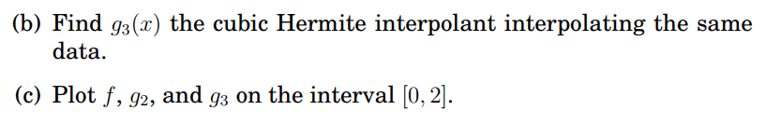

Where y1 is f, y2 is g2 and y3 is g3. Graph is made by Desmos. This is a closer look



Plugging in t = (x – a)/h, we have:



Compute the general form of the coefficients:







In exercise 1, we have a = 0, f(a) = 0, f’(a) = 0, b = 2, f(b) = 16, f’(b) = 32 and h = 2

=> 

=> 

=>

Plugging into p(t), we have:



We have get the same cubic Hermite interpolation like Exercise 1



For the first spline, we have a = 0, p1(a) = 0, p1’(a) = 0, z = 1, p1(z) = 0, p’(z) = 0 and h = 1





The final constraint, where z = 1, is given by



=> The corresponding quadratic Hermite interpolant g(x) in Bernstein form is:





=> 

=> as g2(x) the quadratic Hermite interpolation in Exercise 1

The Matlab code for quadhermite.m is  
function hermiteQuadCoeff = quadhermite(a, b, z, y1, y2, s1, s2)

c10 = y1;

c22 = y2;

d = 2;

hSpline1 = z - a;

hSpline2 = b - z;

derivativeA = s1;

derivativeB = s2;

c11 = (derivativeA * hSpline1 / d) + c10;

c21 = c22 - (derivativeB * hSpline2 / d);

c120 = (hSpline1 * c21 + hSpline2 * c11)/(hSpline1 + hSpline2);

hermiteQuadCoeff = [c10, c11, c120, c21, c22];

end

The result of the quadhermite function is:

The Matlab code for quadhermite_test.m is

vars = num2cell([0,2,1,0,16,0,32]);

[a,b,z,y1,y2,s1,s2] = deal(vars{:});

C = quadhermite(a,b,z,y1,y2,s1,s2);

t = 0:1/n:1;

t2 = 1:1/n:2;

B10 = (1-t).^2;

B11 = 2*t.*(1-t);

B12 = t.^2;

B20 = (1-t).^2;

B21 = t*2.*(1-t);

B22 = t.^2;

x2 = [a:(z-a)/n:z,z:(b-z)/n:b];

g2 = [C(1).*B10 + C(2).*B11 + C(3).*B12, C(3).*B20 + C(4).*B21 + C(5).*B22];

x3 = 2*t;

B30 = (1-t).^3;

B31 = 3*t.*((1-t).^2);

B32 = 3*(t.^2).*(1-t);

B33 = t.^3;

g3 = [0.*B30 + 0.*B31 - 16/3.*B32 + 16.*B33];

f2 = x2.^4;

f3 = x3.^4;

subplot(1,2,1)

plot(x2,g2,x3,g3,'--',x3,f3,'-.')

title('Function and interpolants')

subplot(1,2,2)

plot(x2,g2-f2,x3,g3-f3,'--')

title('Errors')

The function, interpolants and the errors are in the graph below:  
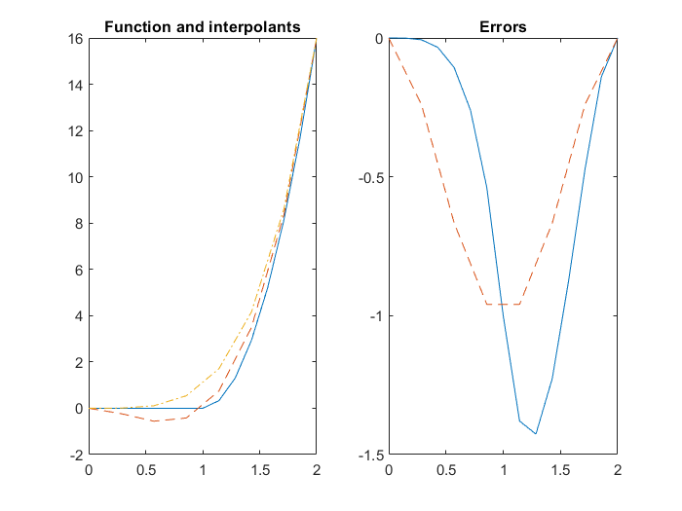

The Matlab code for drawing_initials.m is

% My initials are N.X.B

% Drawing initial N

x = [1 1.5 2 2.5]; y = [1 3 1 3];

n = length(x);

t = 0:1:n-1;

tt = 0:.1:n-1;

xx = spline(t,x,tt); yy = spline(t,y,tt); hold on

plot(xx,yy','b','LineWidth',2), plot(x,y,'o'), grid on

% Drawing initial X

x = [3 3.5 4 4.5]; y = [1, 1.25, 2.75, 3];

n = length(x);

t = 0:1:n-1;

tt = 0:.1:n-1;

xx = spline(t,x,tt); yy = spline(t,y,tt); hold on

plot(xx,yy','g','LineWidth',2), plot(x,y,'o'), grid on

x = [3 3.5 4 4.5]; y = [3, 2.75, 1.25, 1];

n = length(x);

t = 0:1:n-1;

tt = 0:.1:n-1;

xx = spline(t,x,tt); yy = spline(t,y,tt); hold on

plot(xx,yy','g','LineWidth',2), plot(x,y,'o'), grid on

% Drawing initial B

x = [5 5.5 5]; y = [1, 2, 3];

n = length(x);

t = 0:1:n-1;

tt = 0:.1:n-1;

xx = spline(t,x,tt); yy = spline(t,y,tt); hold on

plot(xx,yy','r','LineWidth',2), plot(x,y,'o'), grid on

x = [5 6 6.5 5.5]; y = [1, 1, 1.5, 2];

n = length(x);

t = 0:1:n-1;

tt = 0:.1:n-1;

xx = spline(t,x,tt); yy = spline(t,y,tt); hold on

plot(xx,yy','r','LineWidth',2), plot(x,y,'o'), grid on

x = [5 6 6.5 5.5]; y = [3, 3, 2.5, 2];

n = length(x);

t = 0:1:n-1;

tt = 0:.1:n-1;

xx = spline(t,x,tt); yy = spline(t,y,tt); hold on

plot(xx,yy','r','LineWidth',2), plot(x,y,'o'), grid on

The drawing of my initials N.X.B is given using Spline (I can also use Bezier curves but it requires many control points so I use the default Matlab spline function for simplicity)

